Diccionario
- SKU: SKU is a unique identifier assigned to a specific product or item in inventory. Each variation of a product has its own SKU. For example, a red T-shirt in size medium may have a different SKU than the same T-shirt in size large or in blue
- Backorder: ocurre cuando un cliente solicita un producto que no está disponible en inventario en ese momento, pero la empresa aún acepta el pedido y lo enviará más tarde una vez que el producto vuelva a estar disponible.
- PSR (Projected Stock Requirement): La cantidad estimada de inventario necesario para satisfacer la demanda futura esperada.
- PSR vs RR: PSR is the input for Internal & External Manufacturing; RR is the input for LSP planners.
- LSP: Proveedor de Servicios Logísticos, y se refiere a una empresa externa que se encarga de gestionar parte o toda la cadena logística de otra empresa.
- ADD (Average Daily Demand): Es una métrica que representa cuántas unidades de un producto (SKU) se venden o se consumen en promedio por día, calculada a partir de datos históricos.
- FF Data Lag: refers to the time difference between when a transaction or inventory change actually happens and when that data is reflected in the system used for planning (like PSR/RR). If FF Data Lag is -2 Days, then the inventory or shipment data available today actually reflects the situation from 2 days ago.

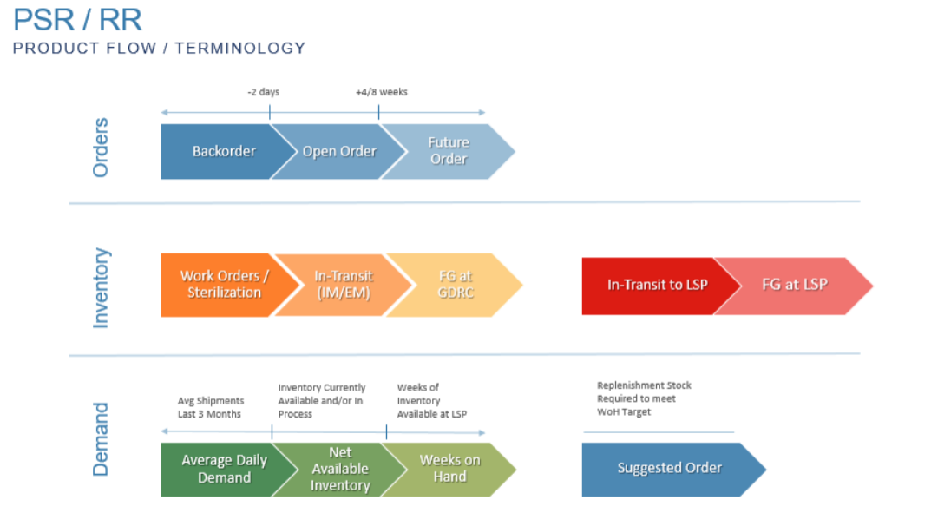
🔵 Orders (Top Row)
- Backorder:
  - Customer demand that couldn’t be fulfilled immediately due to insufficient inventory.
  - Typically occurs up to 2 days before stock becomes available.
- Open Order:
  - Confirmed customer orders that are being processed but not yet fulfilled.
  - Fulfillment is expected within the next 4–8 weeks.
- Future Order:
  - Orders placed with a lead time beyond the standard fulfillment window (4–8 weeks).
  - Planning tool for forecasting future demand.

🟠 Inventory (Middle Row)
- Work Orders / Sterilization:
  - Products are currently in production or sterilization phase.
  - Not yet available for shipment or sale.
- In-Transit (IM/EM):
  - Items that have been shipped (either internationally (IM) or externally (EM)) but not yet received at the GDRC (Global Distribution and Return Center).
- FG at GDRC (Finished Goods at Global Distribution and Return Center):
  - Completed and sterilized inventory that is ready for distribution.
- In-Transit to LSP:
  - Inventory that is currently on its way to the LSP (Local Service Provider).
- FG at LSP (Finished Goods at Local Service Provider):
  - Final stock available at the local level and ready to be delivered to customers.

🟢 Demand (Bottom Row)
- Average Daily Demand:
  - The average quantity of items shipped per day, based on the last 3 months of data.
- Net Available Inventory:
  - Total inventory currently available for fulfillment, including what is in process.
- Weeks on Hand:
  - The number of weeks the current inventory can support, based on the average daily demand.
- Suggested Order:
  - The amount of inventory that needs to be replenished to meet the Weeks on Hand (WoH) target.
  - Helps prevent stockouts or overstocking.

